**My First Assignment in Internship**

* Folder open in VS Code
* File created with content visible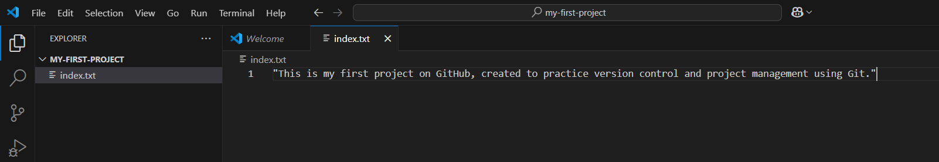
* 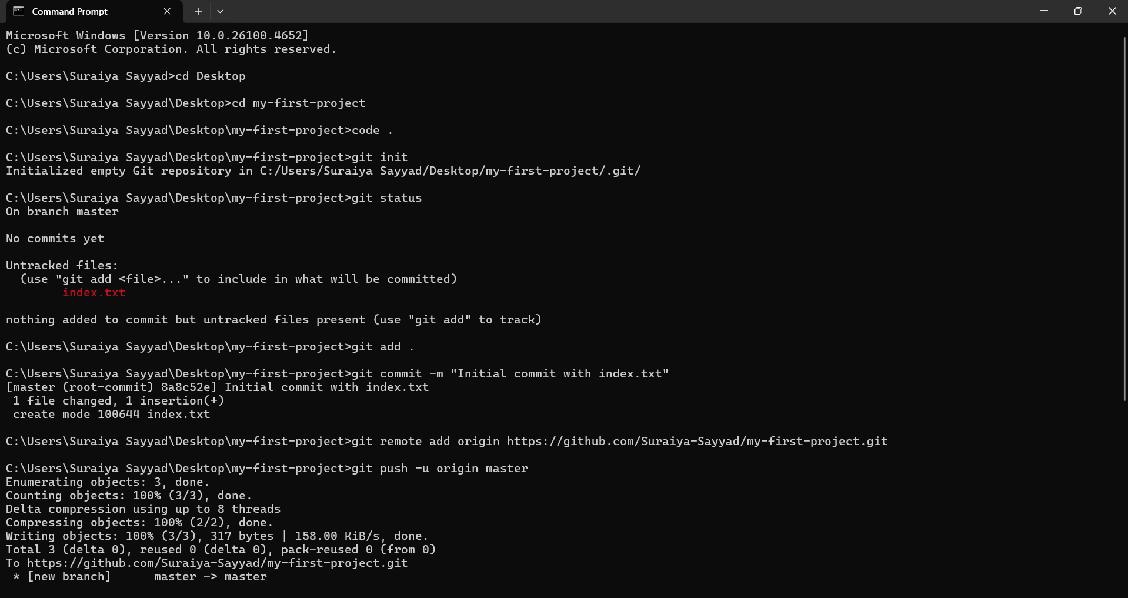Git terminal with key steps (e.g., init, commit, push)
* GitHub repository showing your pushed file

